Name: jomol R.k
Roll No:9
Batch:s2 mca -B
Date:23/5/2022

NETWORKING & SYSTEM ADMINISTRATION LAB

Experiment No.: 24

Aim
Steps for installing Docker

Procedure
1. Open the terminal on Ubuntu.
2. Remove any Docker files that are running in the system
command:
$ sudo apt-get remove docker docker-engine docker.io
After entering the above command, you will need to enter the password of the root and press enter.
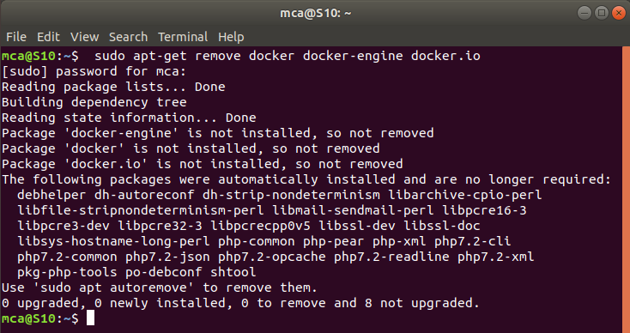

3. Check if the system is up-to-date
command:
$ sudo apt-get update
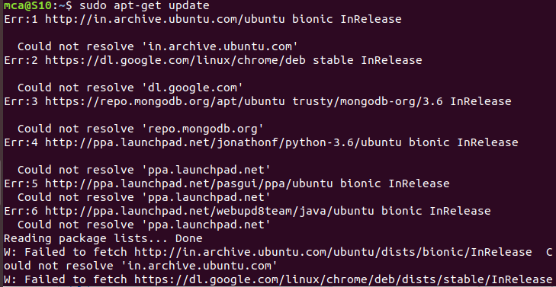
4. Install Docker
command:
$ sudo apt install docker.io
You’ll then get a prompt asking you to choose between y/n - choose y

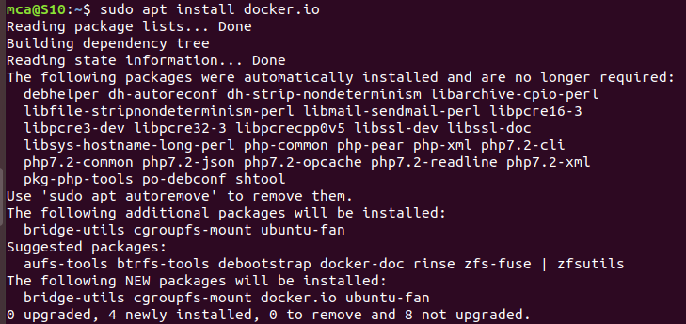
5. Install all the dependency packages
command:
$ sudo snap install docker
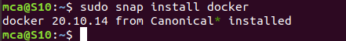
6. Before testing Docker, check the version installed
command:
$ docker –version
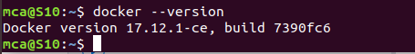

7. Pull an image from the Docker hub
command:
$ sudo docker run hello-world
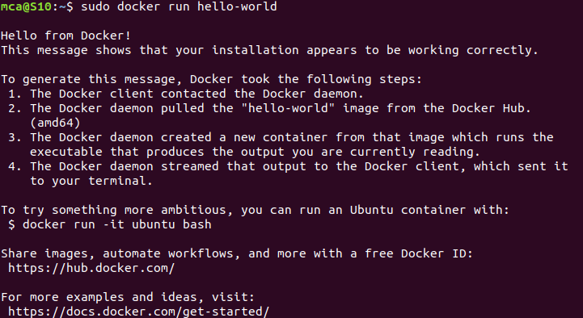

8. Check if the docker image has been pulled and is present in your system
command:
$ sudo docker images
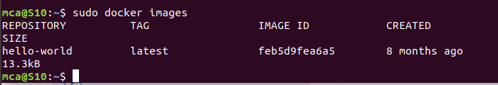
9. To display all the containers pulled
command:
$ sudo docker ps -a
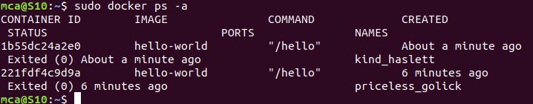
10. To check for containers in a running state
command:
$ sudo docker ps
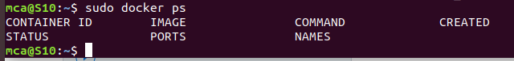

successfully installed Docker on Ubuntu!

